**IOT BASED RIVER WATER QUALITY MONITORING SYSTEM**

**USING IBM WATSON**

**ABSTRACT**

Water pollution is one of the biggest fears for the green globalization. In order to ensure the safe supply of the drinking water the quality needs to be monitor in real time. In this paper we present a design and development of a low cost system for real time monitoring of the water quality in IOT(internet of things).The system consist of several sensors is used to measuring physical and chemical parameters of the water. The parameters such as temperature, PH, turbidity, flow sensor of the water can be measured. The measured values from the sensors can be processed by the core controller. The can be used NodeMCU a core controller. Finally, the sensor data can be viewed on internet using WI-FI system.

**INTRODUCTION**

In the 21st century, there were lots of inventions, but at the same time were pollutions, global warming and so on are being formed, because of this there is no safe drinking water for the world’s pollution. Nowadays, water quality monitoring in real time faces challenges because of global warming limited water resources, growing population, etc. Hence there is need of developing better methodologies to monitor the water quality parameters in real . The water quality parameters pH measures the concentration of hydrogen ions. It shows the water is acidic or alkaline. Pure water has 7pH value, less than 7pH has acidic, more than 7pH has alkaline. The range of pH is 0-14 pH. For drinking purpose it should be 6.5-8.5pH. Turbidity measures the large number of suspended particles in water that is invisible. Higher the turbidity higher the risk of diarrheoa, collera. Lower the turbidity then the water is clean. Temperature sensor measures how the water is, hot or cold. Flow sensor measures the flow of water through flow sensor. The traditional methods of water quality monitor involves the manual collection of water samples from different locations.

**PROPOSED SYSTEM:**

In this, we present the theory on real time monitoring of water quality in IoT environment. The overall block diagram of the proposed method is explained. Each and every block of the system is explained in detail. In this proposed block diagram consist of several sensors (temperature,turbidity,DHT11) is connected to core controller. The core controller are accessing the sensor values and processing them to transfer the data through internet. NodeMCU is used as a core controller. The sensor data can be viewed on the IBM Cloud.

**Turbidity sensor** :

Turbidity is a measure of the cloudiness of water. Turbidity has indicated the degree at which the water loses its transparency. It is considered as a good measure of the quality of water. Turbidity blocks out the light needed by submerged aquatic vegetation. It also can raise surface water temperatures above normal because suspended particles near the surface facilitate the absorption of heat from sunlight.

**Specifications**

|  |
| --- |
| **Range***:*Sensor=0-50 NTU and 0-1000 NTU; Meter=0-50 NTU or 0-1000 NTU selectable **Accuracy***:* + 1% of full scale **Meter****Resolution***:* 12 bit **Output***:* 4-20mA (Sensor, both ranges), LED screen (Meter) **Method***:* Nephelometer with correction **Operating*****Voltage****:* 10-36 VDC @ 40 MS (Sensor); Internal 9VDC battery (Meter) **Operating****Temperature***:* 14 to 122°F (-10 to +50°C) (Sensor); 32 to 122°F (0 to +50°C) (Meter) **Materials***:* 306 stainless steel, delrin, polyether jacketed cable. **Light****Source***:* Infrared LED, (880nm) |

|  |
| --- |
|  |

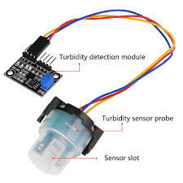

**Fig: Turbidity sensor**

**Temperature sensor**:

Water Temperature indicates how water is hot or cold. The range of DS18B20 temperature sensor is -55 to +125 °C. This temperature sensor is digital type which gives accurate reading.

**Specifications**

**Range**: 0°...100°C

**No of Sensors**: 1 to 30

**Type:** 5kOhm NTC-resistors Max. wirersistance 3,3Ohm

**Conditioner**:Wheatstone-bridge with+15 Bits ADC

**Calibration**: at 0°C and 100°C _ 0,1°C

|  |  |  |
| --- | --- | --- |
|  |  |  |
|  |  |  |
|  |  |  |
|  |  |  |
|  |  |  |

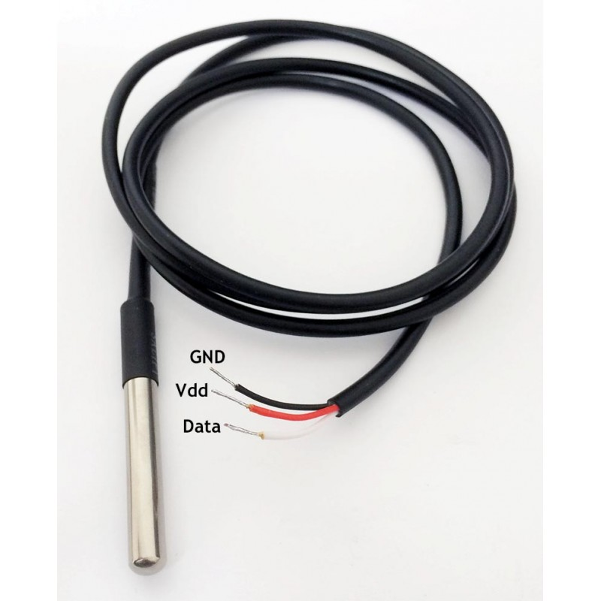

**Fig: Temperature sensor**

**NodeMCU**:

NodeMCU is an open source development board and firmware based in the widely used ESP2866-12E WiFi Module. It allows you to program  the ESP8266 WiFi module with the simple and Powerful LUA Programming language or Arduino IDE. With just a few lines of code you can establish a WiFi connection and define input/output pins according to your needs exactly like arduino, turning your ESP8266 into a web server and a lot more. It is the WiFi equivalent of ethernet module. Now you have internet of things (iot) real tool.

With its USB-TTL , the nodeMCU bread-board supports directly flashing from USB port. It combines features of WIFI accesspoint and station + microcontroller. These features   make the NodeMCU extremly powerful tool for Wifi networking. It can be used as access point and/or station, host a webserver or connect to internet to fetch or upload data.

Features

Finally, programable WiFi module.

Arduino-like (software defined) hardware IO.

Can be programmed with the simple and powerful Lua programming language or Arduino IDE.

 USB-TTL included, plug & play.

10 GPIOs D0-D10, PWM functionality, IIC and SPI communication, 1-Wire and ADC A0 etc. all in one board.

Wifi networking (can be used as access point and/or station, host a web server), connect to internet to fetch or upload data.

Event-driven API for network applications.

PCB antenna.

[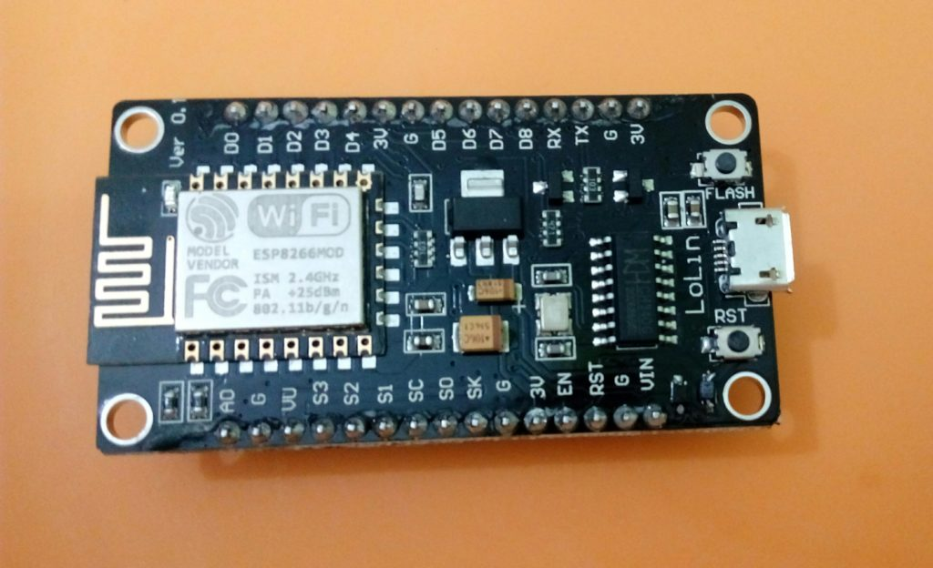](https://www.ahirlabs.com/wp-content/uploads/2017/09/NodeMcu.jpg)  **Fig:NodeMcu ESP8266**

**NodeMCU Specifications:**

**Developer :** ESP8266 Opensource Community  
**Type :**  Single-board microcontroller  
**Operating system :** XTOS  
**CPU :** ESP8266  
**Memory :** 128kBytes  
**Storage :** 4MBytes  
**Power By :** USB  
**Power Voltage :** 3v ,5v (used with 3.3v Regulator which inbuilt on Board using Pin VIN)  
**Code :** Arduino Cpp  
**IDE Used :** Arduino IDE  
**GPIO :** 10

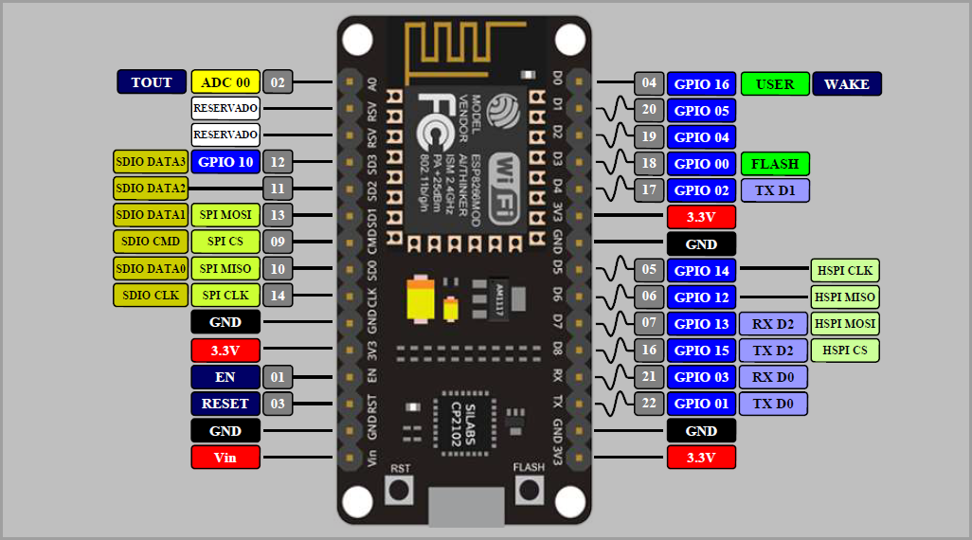

**Fig: NodeMCU**

**Wi Fi module**:

ESP8266-12 (ESP-12) is the enhanced version of ESP8266 WIFI module. The ESP8266-12 has an integrated 80 MHz microcontroller with a full WiFi capability  (both as client and access point) and TCP/IP stack with DNS support as well.

Compared to ESP8266, The The ESP8266-12 onboard antenna impedance matching was modified to improve output signal strength and quality.  Both stability and RF interference resistance has been improved to reduce the data losses during transmit and receive. It has the additional six pins with IO and SPI ports which allow more freedom to the developer.

ESP8266-12 has powerful on-board processing and storage capabilities that allow it to be integrated with the sensors and other application specific devices through its GPIOs with minimal development . It is designed to occupy minimal PCB area.

Applications

Home automation

Sensors network

Industrial wireless control

IP cameras

Baby monitor

WIFI position system beacon

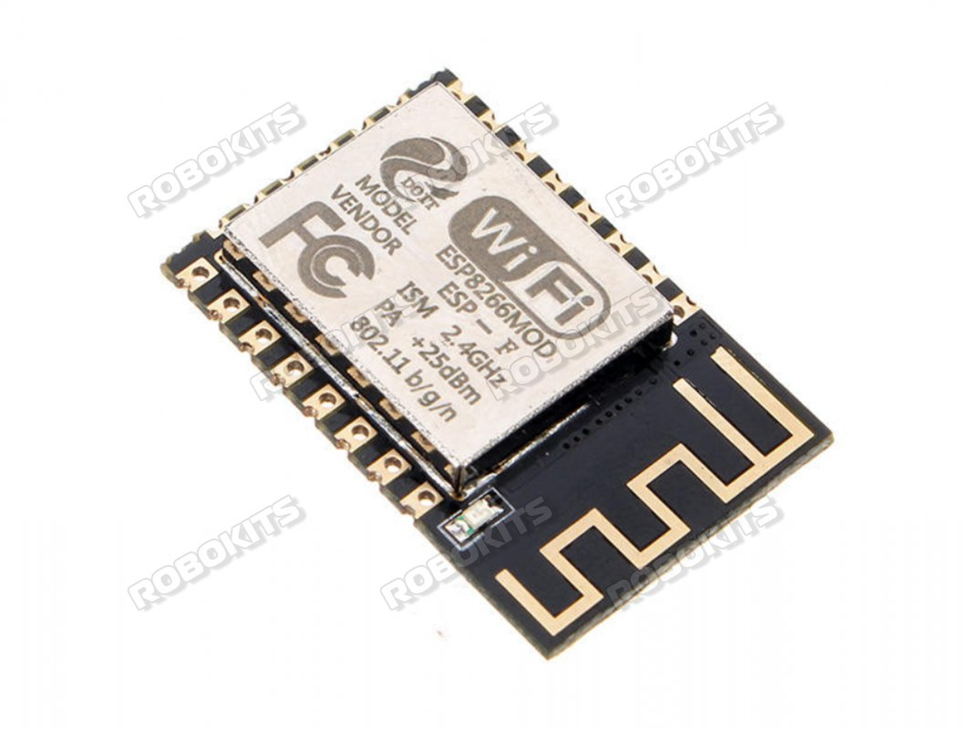

**Fig: WiFi ESP8266MOD**

**DTH11 Temperature and Humidity Sensor:**

This DHT11 Temperature and Humidity Sensor features a calibrated digital signal output with the temperature and humidity sensor capability. It is integrated  with a high-performance 8-bit microcontroller. Its technology ensures the high reliability and excellent long-term stability.  This sensor includes a resistive element and a sensor for wet NTC temperature measuring devices. It has excellent quality, fast response, anti-interference ability and high performance.

Each DHT11 sensors features extremely accurate calibration of humidity calibration chamber. The calibration coefficients stored in the OTP program memory, internal sensors detect signals in the process, we should call these calibration coefficients. The single-wire serial interface system is integrated to become quick and easy. Small size, low power, signal transmission distance up to 20 meters, enabling a variety of applications and even the most demanding ones. The product is 4-pin single row pin package. Convenient connection, special packages can be provided according to users need.

**Specifications**

* **Supply Voltage**: +5 V
* **Temperature range** :0-50 °C error of ± 2 °C
* **Humidity** :20-90% RH ± 5% RH error
* **Interface**: Digital

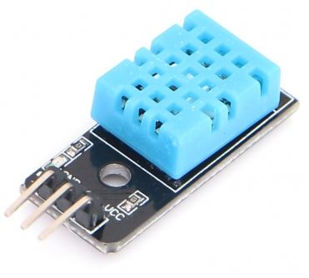

Fig: DHT11 Sensor

**DATA SHEETS:** <https://www.mouser.com/ds/2/758/DHT11-Technical-Data-Sheet-Translated-Version-1143054.pdf>

<https://www.terraelectronica.ru/pdf/show?pdf_file=%2Fz%2FDatasheet%2F1%2F1420644897.pdf>

**PROJECT WORKING PROCESS:**

* In this project we intend to present the design and development of a low cost system for real monitoring of water quality in an IoT environment. The system consists of several sensors which are used for measuring physical and chemical parameters of water.
* Using this system a person can detect pollutants from a water body from anywhere in the world. We can monitor the water quality parameters by using some sensors and these sensor parameters are sent to the IBM Watson cloud and stored in the data base. These parameters are visualized in the User Interface which is created using Node Red of IBM Watson platform. Whenever the water quality is not good we can send notifications to authorities through the third party services.

**Complete Project Working Process**

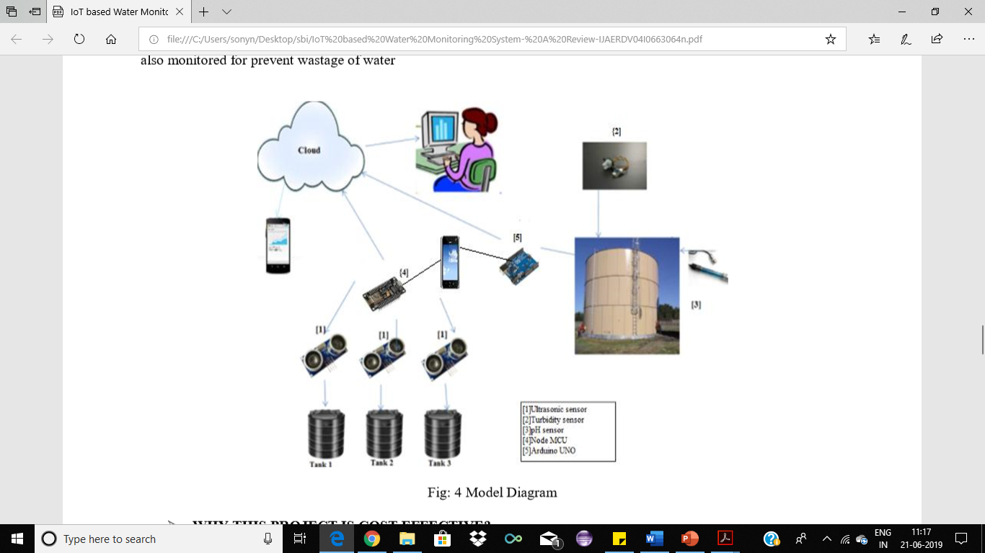

INSTALLATIONS

<OneWire.h>

<DallasTemperature.h>

<ESP8266WiFi.h>

<PubSubClient.h>

<Adafruit_SSD1306.h>

<Adafruit_GFX.h>

